Instructions for building the models of the Astroset Moon and Planets

General
This document contains the instructions to build our Astroset Maan en Planeten (Moon and Planets), which is currently only published in Dutch. However, this Astroset should be simple to build for others with these instructions and the user guide which contains the translations of all the Dutch words shown on the models.
There will be a more complete looking set of building instructions to build the models, with pictures, in the near future, as a downloadable PDF.
If you miss necessary information in these instructions, please let us know via info@walrecht.nl. With your input we can improve it.

First read the following text carefully and at every stage consider the next steps, before you cut, score or glue!

Please note: don’t let children use hobby knives and pins!

Earth-Moon model

What do you need to build the Earth-Moon model?
Wood glue (or mounting kit), possibly double sided adhesive tape, a pair of scissors, a sharp hobby knife, a drawing pin (thumb tack), a piece of 2mm-thick grey backing board measuring at least 12 x 17 cm, two sizable cocktail sticks or round wooden rods (2mm diameter, at least 6.5 cm long); and two wooden beads, one of 8mm and one of 15mm (approximately). Preferably use a hobby cutting mat.

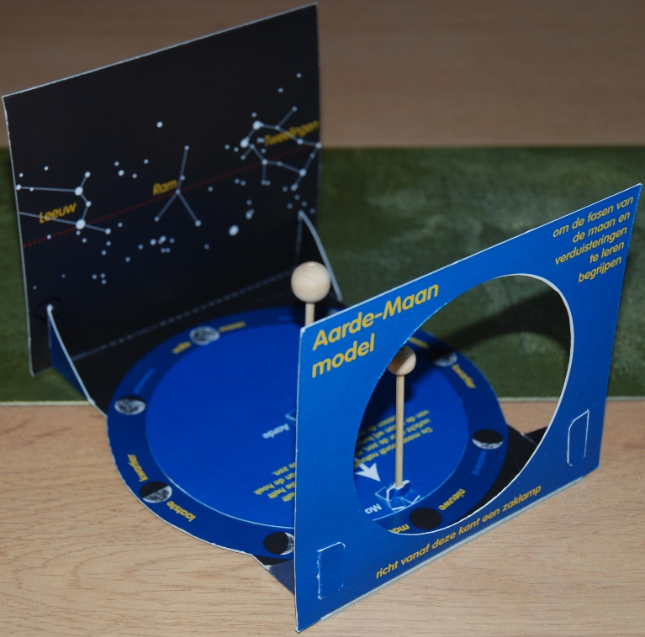

The Earth-Moon model when built, with a part of the night sky in the background, with the constellations Gemini, Aries and Leo, through which runs the ecliptic (Sun’s path).

What do you have to do?
- Cut out the big shape (A-D, letters shown outside the shape), the circle E and two of the small standards for the Earth and the Moon (F, two reserves!).
- The white dotted lines in the big shape and in the small standards are folding lines (do not cut these). Folding along these lines later on is easier if you first score the card by running along these lines with a ball point or the side of a pair of scissors, using a ruler or straight edge as your guide.
- Cut the large shape and the small standards along the continuous white lines, and also the four thick white lines on A and B (these are wider slots, see point 4).
- Fold the ‘feet’ of the small standards upwards and the two wings of the standards towards each other. Fold them neatly around the wooden rods, making sure the rods are perpendicular to the feet. See the illustration below.
- Fold the parts A, B, and D upwards (black surfaces facing inwards). Slide the ‘parts’ C through the slots in A and B. Glue these parts to the (blue) front and backsides of the Earth-Moon model, in such a way that the letter ‘C’ cannot be seen any longer.

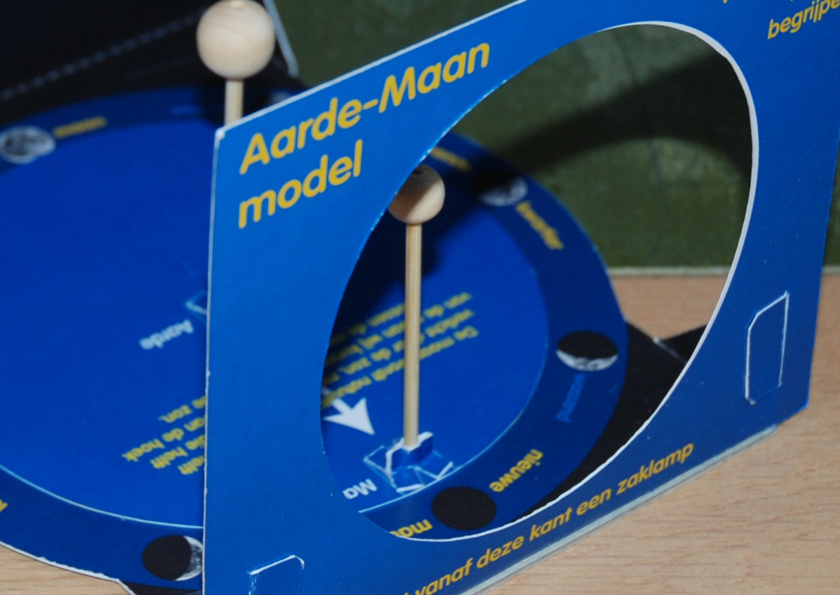

- Cut the rods to approx. 7cm*, and glue* the beads onto them, a 15mm bead for the Earth, an 8mm bead for the Moon. Put the rods all the way through the holes of the beads, closing these holes neatly (you can file or sand them, when the glue has dried, to return to the sphere shapes).
* You can make the rods a little longer and cut them to the correct size afterwards. The centre of the two beads should be level with the ecliptic, the red dotted line on the little star chart (the background of the Earth and Moon when the model is ready).
- For the best result you can paint the beads and rods: the large bead (Earth) blue (or more precise, depending on your skills) and the small one (Moon) yellow (although the Moon is actually a dark shade of grey…). Paint the rods black so they don’t stand out.
- Cut the rods to the correct length (see note under point 6).
- If you have a little hobby drilling machine with very thin drills, you can drill holes in the rod for the Earth, where later the drawing pin will enter the rod. If you don’t have a drilling machine you can use a pin or drawing pin to make the hole but be careful with your fingers!
- Now make holes in the round disc (E) and in the large shape at ‘X’, using the drawing pin and a soft surface below it (a cutting mat, or else some magazine).
- Glue the side of each rod without a bead between the two wings of a standard and press them together so as to have the standard completely enclose the rod.
- After drying the glue, you can make the sides of the standards and any damage black, with a black marker or hobby paint.
- Put the drawing pin through the holes you made in the bottom part and place the round disc on it (see point 10).
- Glue the four little ‘feet’ of both standards on the round disc (E), on the marked spots (circle with two crossed lines inside; incidentally that sign is also the symbol for Earth!). Make sure that the hole in the rod slides neatly over the drawing pin and is then glued to ‘E’. Mind your fingers!
- Stick a few pieces of adhesive tape over the head of the pin, on the bottom side, to make sure it can’t fall out. For more sturdiness you can stick the model on a 12 x 17 cm large and 2mm thick backing grey board.
- Your Earth-Moon model is now ready for use!!

*) For some parts it is better to use mounting kit than wood glue, as mounting kit also works as a filler, and can be sanded afterwards.
Table Planetarium

What do you need to build the Table Planetarium?
Wood glue, possibly double sided adhesive tape, a pair of scissors, a sharp hobby knife, two drawing pins (thumb tacks), two pieces of 1mm-thick grey backing board measuring 30cm diameter, two sizable cocktail sticks or round wooden rods (2mm diameter, at least 6.5 cm long, and five wooden beads, two of 8mm, two of 10mm and one of 15mm (approximately). Preferably use a hobby cutting mat.

The four sheets for the Table Planetarium are numbered 1 to 4, all the parts have a letter:
- The upright side (double-sided, pre-cut) and a set of special arrows for showing the retrograde movement of planets (‘planetary loops’;
- Large circular bottom of the Table Planetarium, bottom part of the aphelion-perihelion instrument;
- Four circular discs for the planets, the ruler (km and AU, see the User Guide), more retrograde movement arrows, and an explanation of the aphelion-perihelion instrument;
- Bottom part and upright side for the Mars planetary loops extension, even more arrows, the small standards to act as ‘feet’ for the models, upper disc of the aphelion-perihelion instrument.

The letters in the instructions are shown bold, Italic and underscored: for instance A.

What do you have to do?
- The parts A, B and C, on plate 1, all have 15 tabs that will have to be folded later on, to fix the side parts to the bottom. It is best to score (see Earth-Moon model, point 2) them now, along a ruler, before continuing with the next step. You do that along the cuts between the words ‘onder’ (bottom) and the large blue rectangles with the pre-cut holes.
- Cut parts A, B and C out of plate 1, from the blue side (where the folding tabs can be seen).
- Glue parts A, B and C together, with the yellow text on the side leading: ‘C – plak aan A’ means ‘C – glue to A’ (A, B and C are in yellow below the texts). The yellow text parts disappear when you glue them correctly, to the outside of the correct other part. Instead of glue you can use double-sided adhesive tape here; this works immediately which is nice as this part may be tricky: the three parts must be combined in such a way that the result runs straight!
  - NOTE: it is best to have a straight underground, like the side of a table, the hobby cutting mat, or a large ruler, to put the three parts against while gluing or sticking them.
- Cut out the circles (D, E, F, G and H). The largest (D) is the bottom plate.
- Make holes in the centre of all five circles, using a drawing pin on a soft surface (the cutting mat or a magazine). You do that from the top side, even though in the final stages the pin will be entered from the bottom.
- Use the bottom plate (D) as the shape to cut out a nice round piece out of the grey backing board, which you will later stick to the bottom of your Table Planetarium for extra sturdiness.
- Glue or stick the bottom plate (D) inside the (now) upside ring-shaped edge, on the 45 tabs.
  - NOTE: the yellow triangle (arrow) on the bottom plate, the starting point when you want to examine what causes the occurrence of planetary loops, must end its position on the edge of the side-parts A and C: between Maagd (Virgo) and Leeuw (Leo). It is important that you do that carefully as you cannot change it when the parts are stuck together.
- Cut out the parts L1 and L2, which are meant for later fixing the Mars planetary loops extension. Glue L1 en L2 together, insuring that the code ‘L1’ is visible (the centre line is important later).
- Glue (with wood glue, or mounting kit*) the wooden beads on one end of at least 5cm long pieces of rod. Use the large (15mm) bead for the Sun, the two 10mm beads for the Earth and Venus and the two 8mm beads for Mercury and Mars. Put the rods all the way through the beads, ending at the holes (or just beyond them, so you can sand the part that sticks out and nicely rounding off the beads when the glue has dried.
- For the best result you can paint the beads and rods: the large bead (Sun) yellow, Earth blue, Venus white, Mars stone red and Mercury dark grey. Paint the rods black so they don’t stand out.
- Cut the rods at the correct length. That length is determined by the distance between the bottom of the Table Planetarium and the ecliptic (red dotted line) on the inside of the upright side. The centre of the spheres (beads) should be exactly at the same level as the ecliptic!
- If you have a little hobby drilling machine with very thin drills, you can drill holes in the rod for the Sun, where later the drawing pin will enter the rod. If you don’t have a drilling machine you can use a pin or drawing pin to make the hole but be careful with your fingers!
- Glue the side of each rod without a bead between the two wings of a standard and press them together so as to have the standard completely enclose the rod.
- After drying the glue, you can make the sides of the standards and any damage black, with a black marker or hobby paint.
- Push the drawing pin through the hole in the bottom plate, which you made before, from the bottom upwards. Fix the pin with adhesive tape so it can’t fall out.
- Place all planetary discs in the correct order over the drawing pin.
- Glue the standard of the Sun to ‘H’, making sure that the hole in the rod for the Sun slides neatly over the drawing pin. Mind your fingers!
- Glue the ‘feet’ of all other standards on the correct disc (D t/m H), on the marked spots.
- Glue the disc of grey backing board to the bottom (D) of the Table Planetarium, in such a way as to leave the gap in parts L1/L2 free from glue or double-sided adhesive tape, unless you want to fix the Mars planetary loops extension permanently.
- Of J, part of the Mars planetary loop extension (showing the constellations of Virgo and Leo) you now score the tabs, the same way you did with A, B and C. The sides of the limbs with ‘onder’ will be glued to K later.
- Cut out both J and K). Glue the part with the night sky (J) onto the pie-shaped bottom of the extension (K), along the white curved line. The limbs will be on the outside (on the other side of the night sky part).
- Glue L (L1 and L2 combined earlier) on the circular sheet of grey backing board, making sure that the rounded sides run nicely with the round edge of the board.
- Then fill up the rest of the grey backing board disc with thick paper, up to the edge of the disc.
- Glue that combination to the bottom of bottom plate D, making sure that the centre line on L (see point 8) aligns perfectly with the large yellow arrow (and the edge between parts A and C) on the inside of D. The correct alignment is very important when you use the planetarium.
- It is now possible to slide the Mars planetary loops extension into the gap provided by part L, below the planetary loops starting point (the yellow arrow inside).
- Score the folding lines on the small blue arrows and then cut out all of them (there are a few spares). Fold them along the folding lines.
- Glue ONLY the part of each arrow that is coloured light blue on the printed side! You need a free area so you can clamp the arrows on the upright part of the extension.

Now you have just two smaller parts to make: the km/AU ruler and the aphelion-perihelion instrument.
- Cut out the AU ruler, score it (with a ruler) along the white dotted line and fold it along that line. Glue both parts together.
- Cut out both holes (the white circles, for showing the Sun) on N, and the two inner (white) semicircles.
- Then cut out both parts of the aphelion-perihelion instrument (M and N). Push a drawing pin through both parts (M and N), from the top downwards, again on a soft surface. Fold the pin, with a table knife (for safety), until it lies flat on the paper.
- Fix the pin with adhesive tape so it can’t fall out.
- Glue part O over the pin, so you have the user instructions on your instrument and the pin cannot hurt anyone.
- Your Table Planetarium is ready for use!

*) For some parts it is better to use mounting kit than wood glue, as mounting kit also works as a filler, and can be sanded afterwards.

